NAME: MUHAMMED QAISER J
REG NO: 240701621
COMPETITIVE PROGRAMMING
PROGRAM 1: Finding Duplicates-O(n^2) Time Complexity,O(1) Space Complexity
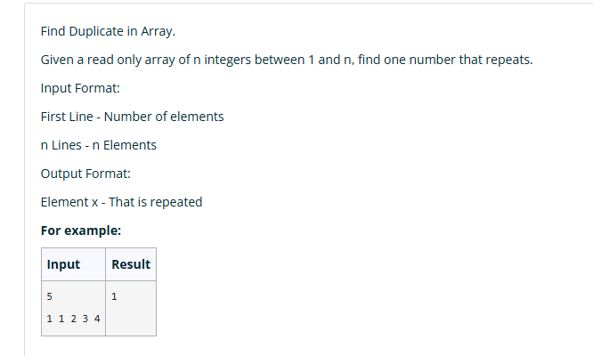
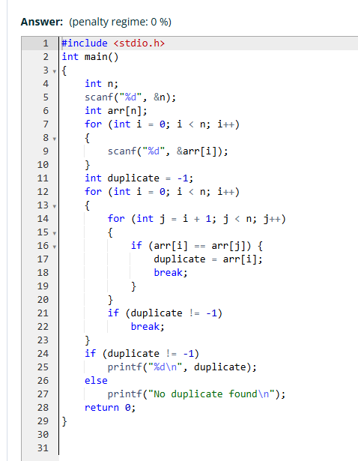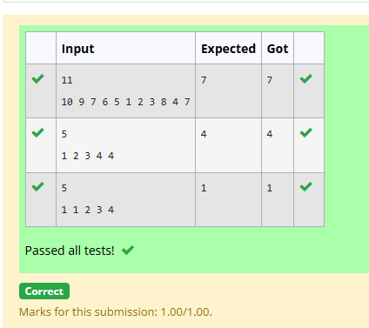
PROGRAM 2: Finding Duplicates-O(n) Time Complexity,O(1) Space Complexity
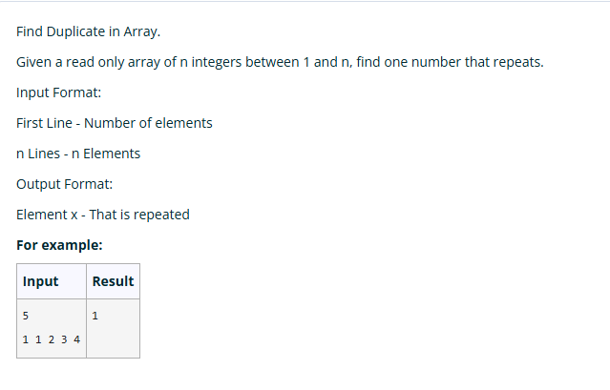
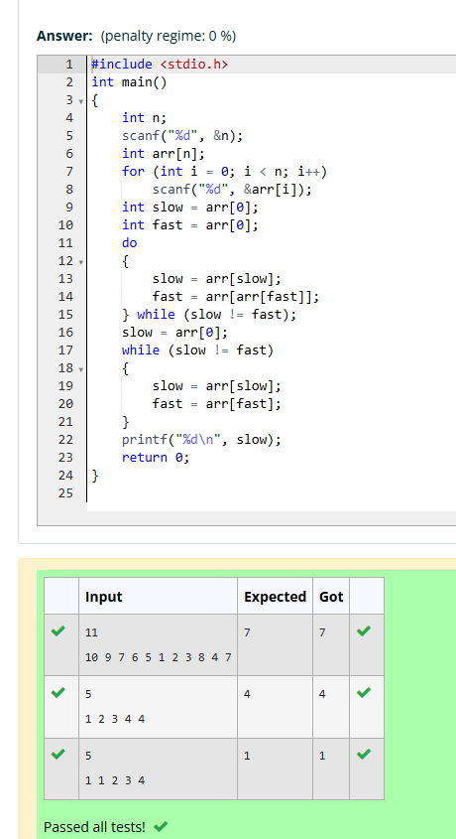

PROGRAM 3: Print Intersection of 2 sorted arrays-O(m*n)Time Complexity,O(1) Space Complexity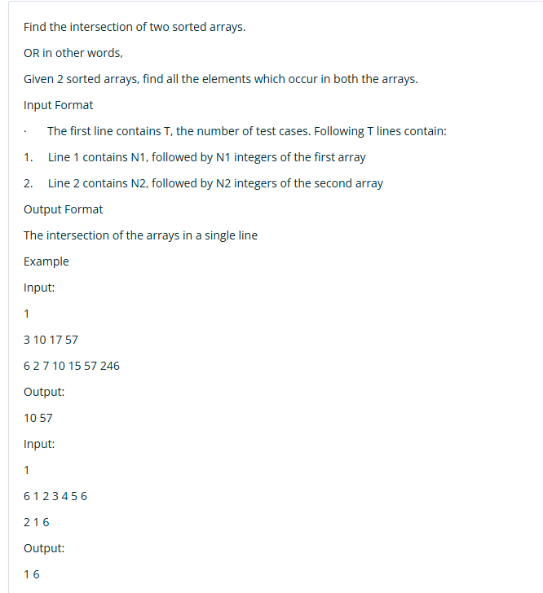
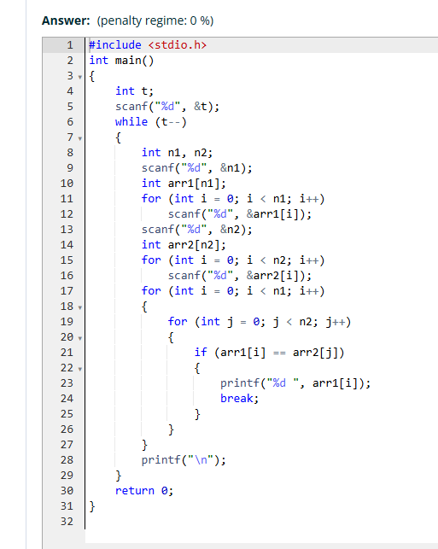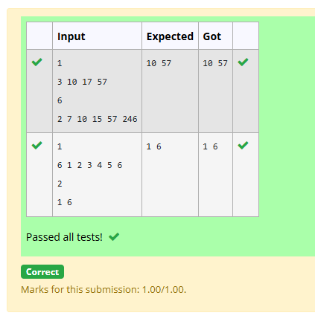
PROGRAM 4: Print Intersection of 2 sorted arrays-O(m+n)Time Complexity,O(1) Space Complexity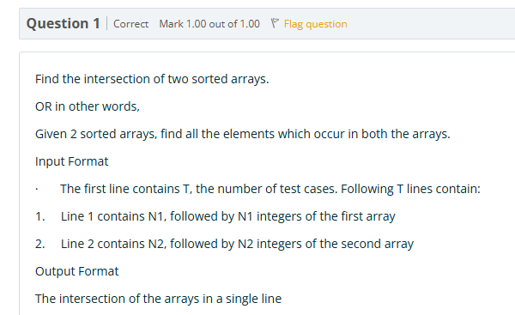
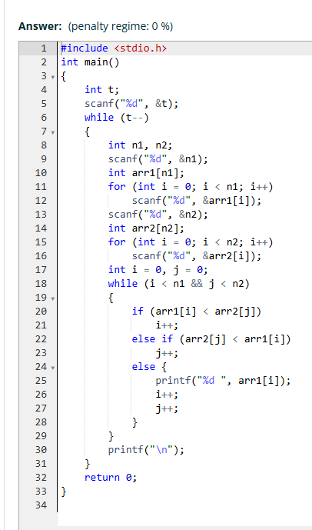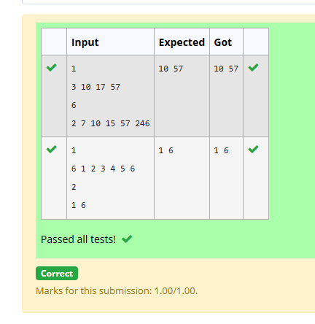
PROGRAM 5: Pair with Difference-O(n^2)Time Complexity,O(1) Space Complexity
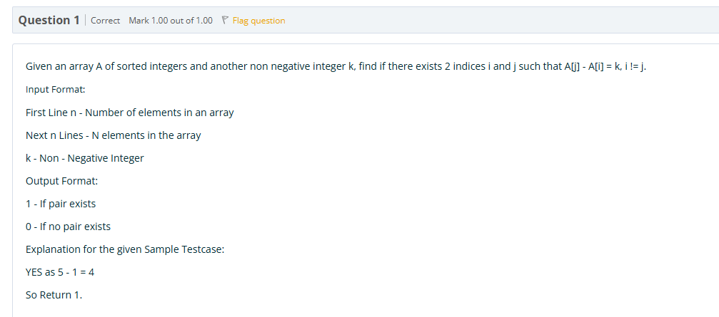
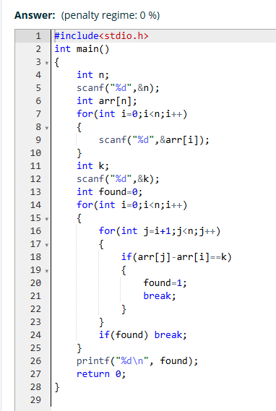
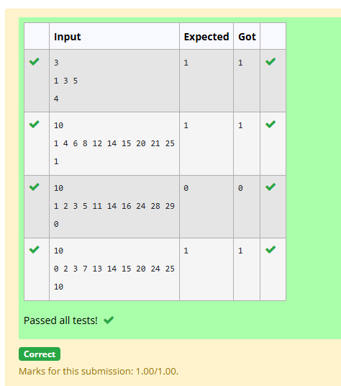

PROGRAM 6: Pair with Difference -O(n) Time Complexity,O(1) Space Complexity
